MI BITÁCORA

STEAM SIN BARRERAS:
CERRANDO BRECHAS EN LA RURALIDAD

GRADO:
__________
NOMBRE:________________________________________
HOLA…
YO SOY _______________________, TENGO__________AÑOS, ME GUSTA IR A LA ESCUELA PORQUE_____________________________ _____________________________________________________________________________________________________________________________________________________________________________________________
MIS MATERIAS FAVORITAS SON: ____________,________________ __________,____________,_____________ PORQUE __________________ ______________________________________________________________________________________________________________________________
CUANDO GRANDE QUIERO SER___________________ COMO_______ __________________PORQUE_____________________________________
______________________________________________________________________________________________________________________________


PREGUNTA GUÍA
_________________________________________________________________________________________________________________________________________________________________________________________________________________________________________________________________________________________________________________________________________________________



RESULTADOS
_________________________________________________________________________________________________________________________________________________________________________________________________________________________________________________________________________________________________________________________________________________________________________________________________________________________________________________________________________________________________________________________________________________________________________________________________________________________________________________________________________________________________________________________________________________________________________________________________________________________________________________________________________________________________________
_________________________________________________________________________________________________________________________________________________________________________________________________________________________________________________________________________________________________________________________________________________________________________________________________________________________________________________________________________________________________________________________________________________________________________________________________________________________________________________________________________________________________________________________________________________________________________________________________________________________________________________________________________________________________________
MIS HIPOTESIS
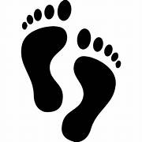

MATERIALES

_________________________________________________________________________________________________________________________________________________________________________________________________________________________________________________________________________________________________________________________________________________________________________________________________________________________________________________________________________________________________________________________________________________________________________________________________________________________________________________________________________________________________________________________________________________________________________________________________________________________________________________________________________________________________________
PROCEDIMIENTO

OBSERVACIONES



REGISTRO

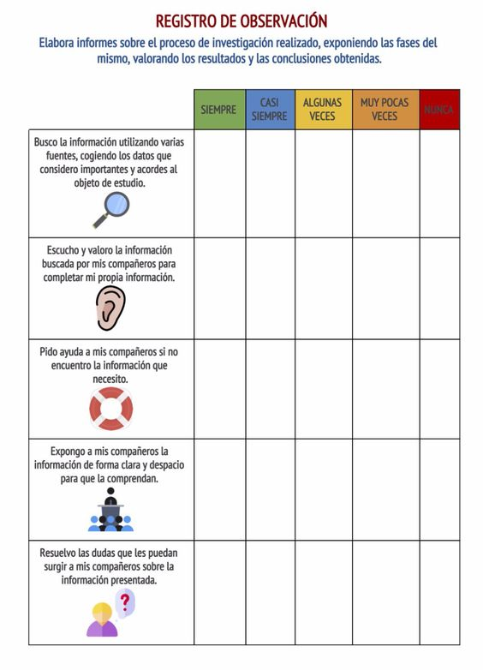


ANÁLISIS
____________________________________________________________________________________________________________________________________________________________________________________________________________________________________________________________________________________________________________________________________________________________________________________________________________________________________________________________________________________________________________________________________________________________________________________________________________________________________________________________________________________________________________________________________________________________________________________________________________________________________________________________________________________________________________________________________________________________________________________________________________________________________________________________________________________________________________________________________________________________________________________________________________________________________________________________________________________________________________________________________________________________________________________________________________________________________________________________________________________________________________________________________________________________________
EVALUACION DEL PROCESO

AUTOEVALUACIÓN
¿ QUE HE
APRENDIDO?
¿COMO LO APRENDÍ?
¿ QUE FUE LO QUE
MÁS ME GUSTÓ ?
¿ COMO ME SENTÍ
DESARROLLANDO
LAS ACTIVIDADES?
ESCRIBO OTRAS
PREGUNTAS QUE
ME SURGIERON

